Joel Atkinson
March 26, 2026
CSD440 Server-Side Scripting
Assignment 1.3

Video Source Used to Configure XAMPP onto my Macbook: https://www.youtube.com/watch?v=dUqMdM7Y5ak
Steps taken to configure XAMPP:
- Searched for XAMPP in Google and navigated to https://www.apachefriends.org and clicked download on the MacOS X 8.2.4 option. This downloaded the .dmg file.
- Went into my downloads and opened the .dmg file and double clicked on the installer icon.
- I received a security warning which I clicked “done” on.
- This was probably the only “hiccup” I had when installing but the video explained what happened to me and how to address it. I went into my system settings, went to privacy and security, scrolled down to where the downloaded file was showing as a threat and clicked Open Anyway. This then opened the installer.
- I then clicked through all of the installer wizard leaving the defaults in place and clicked finish.
- This automatically opened up the XAMPP UI in my browser as well as the XAMPP manager.
- In the XAMPP manager I clicked on the Manage Servers tab and saw that Apache Web Server had a green light next to it showing that it was running (MySQL Database and ProFTPD were red but I just left those as the Bellevue instructional video said we didn’t need to worry about those right away)
- Next to test and confirm the server was running I typed http://localhost into my browser address bar which opened the XAMPP welcome page, proving that the server was in fact running.
- From there I went into my finder and found the XAMPP files including htdocs showing all of the files were correctly downloaded and installed just like in the YouTube instructional video.
- After that I opened my IntelliJ IDE and created a new PHP file with simple PHP code to test everything is working correctly and saved it into my htdocs folder as “JoelFirstProject.php”.
- To test and make sure that my code output correctly I went back to my browser address bar and entered http://localhost/JoelFirstProject.php.
- My browser immediately opened the page with the correct output on the screen proving that everything I had done had worked and was downloaded, set up, and executed correctly.

PHP File Code:
<?php
// Author: Joel Atkinson
// Date: March 25, 2026
// Description: First PHP program demonstrating successful XAMPP installation and configuration
?>
<!DOCTYPE html>
<html lang="en">
<head>
<meta charset="UTF-8">
<title>Joel's First PHP Program</title>
</head>
<body>
<h1><?php echo "Joel Atkinson's First PHP File"; ?></h1>
<h3><?php echo "This is my first PHP file to show that I have successfully installed and configured XAMPP on my MacOS system."; ?></h3>
<p>Below are the steps I took to install and configure XAMPP:</p>
<ol>
<li>Downloaded XAMPP for OS X 8.2.4 from https://www.apachefriends.org</li>
<li>Opened the .dmg installer file from my Downloads folder</li>
<li>Bypassed the macOS security warning by navigating to Privacy & Security and clicking Open Anyway</li>
<li>Clicked through the installer wizard leaving all default settings in place</li>
<li>Opened the XAMPP Manager and confirmed Apache Web Server was running with a green status indicator</li>
<li>Navigated to http://localhost in my browser and confirmed the XAMPP welcome page loaded successfully</li>
<li>Created this PHP file and saved it to the htdocs directory to confirm PHP is functioning correctly</li>
</ol>
</body>
</html>

Screenshots of configuring XAMPP:

Screenshot of webpage with options for download
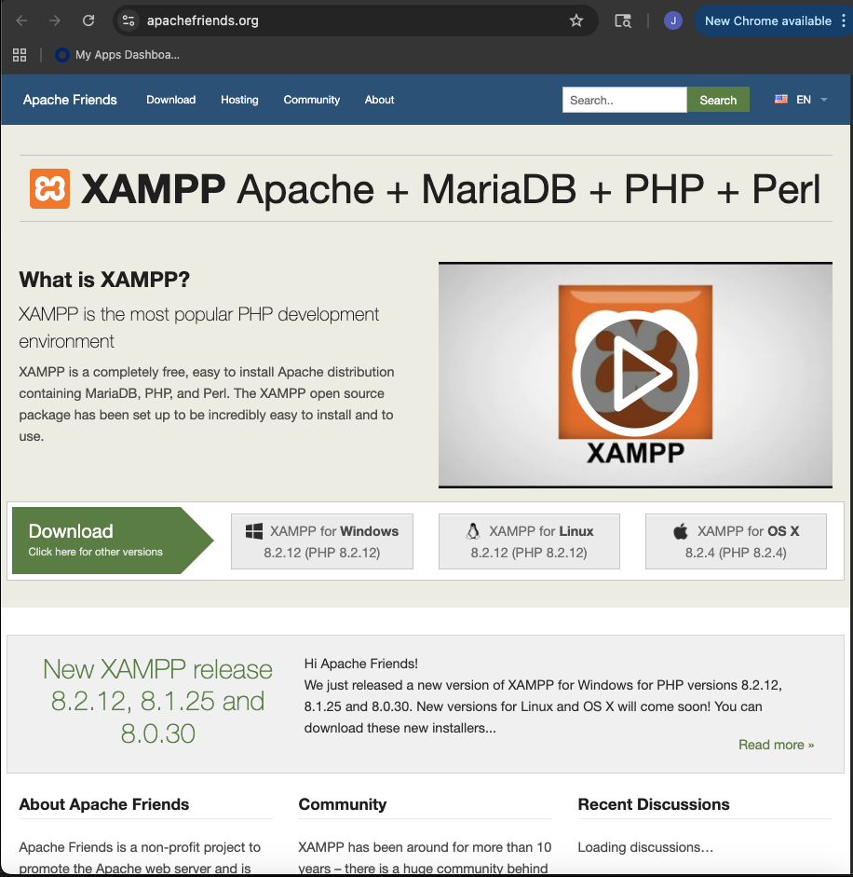
Screenshot of installericon to click to install:
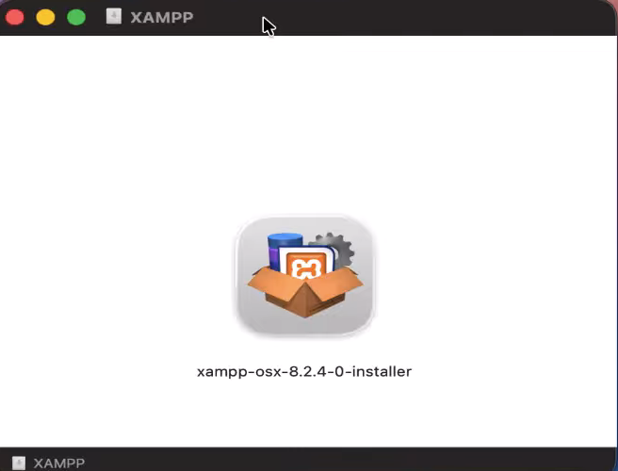
Screenshot of installer wizard:
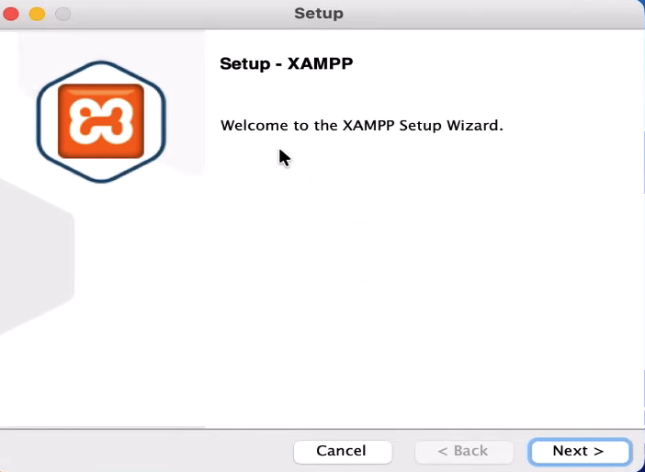
Screenshot of Manager and browser that opened once installed:
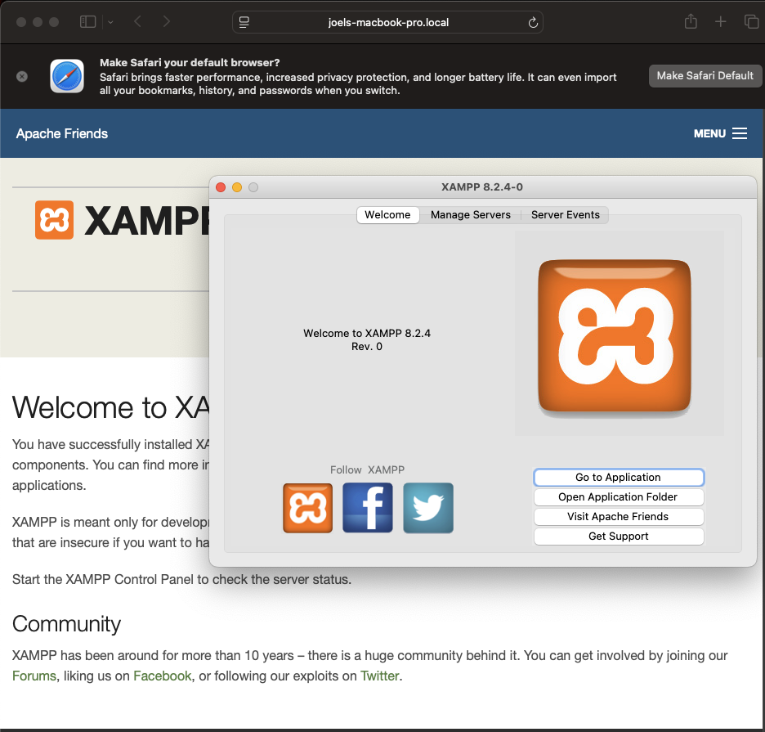
Screenshot of manage servers tab which showed Apache Web Server as green and running:
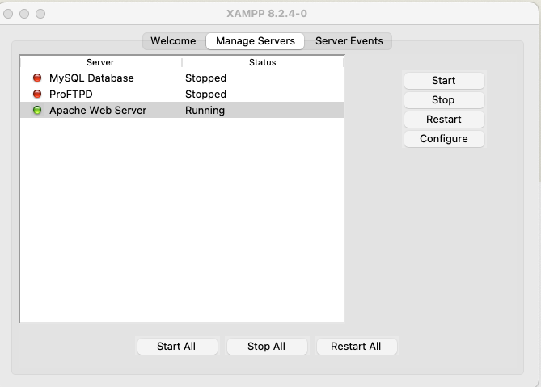
Screenshot of the output when I tested http://localhost in my browser:
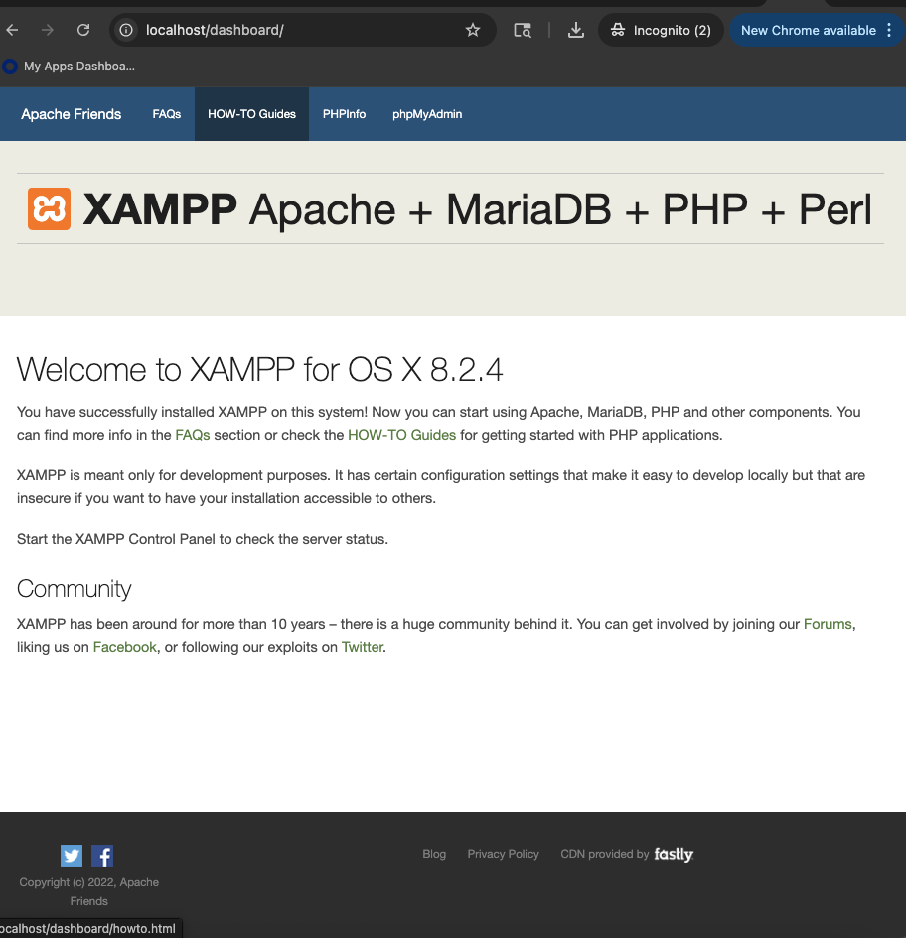
Screenshot of my PHP code in my IDE for my CSD-440 Project:
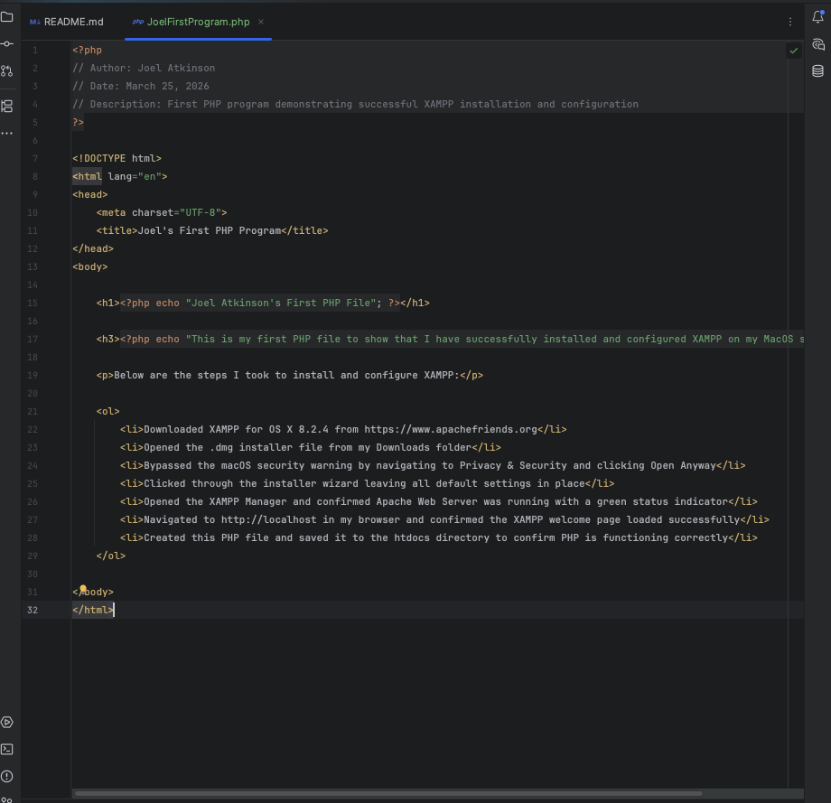
Screenshot of the output from http://localhost/JoelFirstProgram.php:
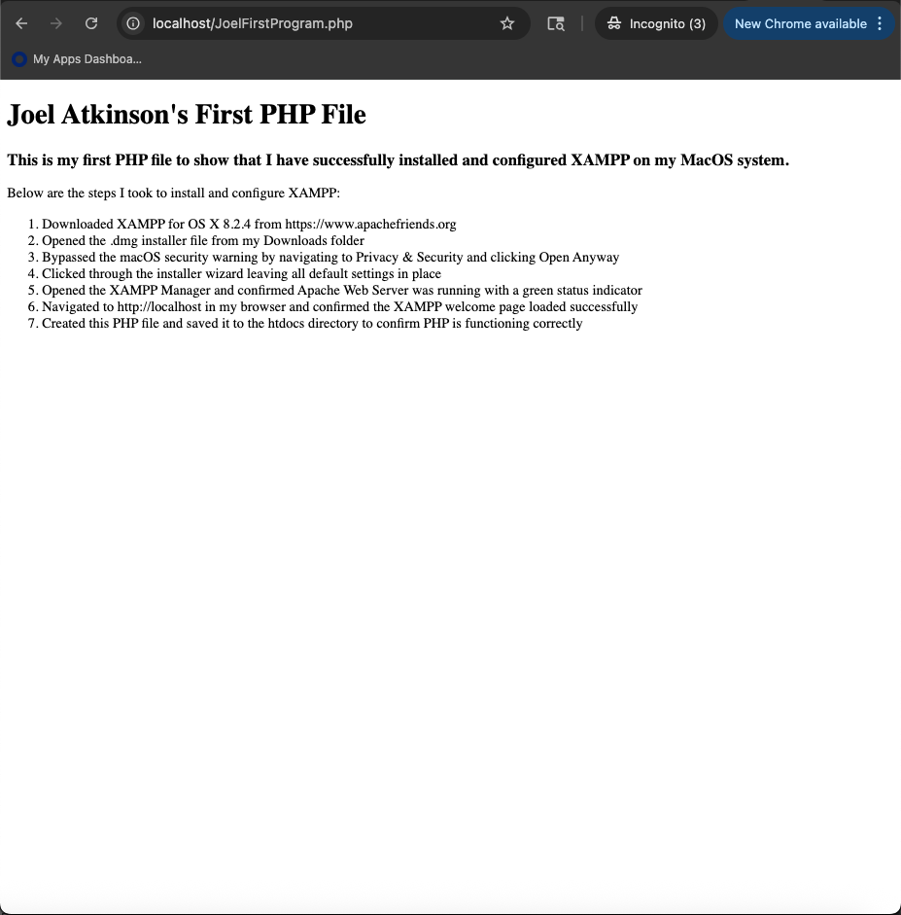

After getting the code written and saved into my CSD-440 project/repo, all I had to do was copy the php file and paste it into my XAMPP htdocs to run it. This allows me to run the file through XAMPP while also having the copied file in my CSD440 repo so I can easily push it to my CSD440 GitHub repo to be reviewed and graded.

